LAB

REPORT

CSE 114 : Data Structure and Algorithms Sessional

|  |  |
| --- | --- |
| PREPARED BY  Mehrin Farzana  ID: 2101013  Session: 2021-2022  Date: 16/07/2023 | SUPERVISED BY  Suman Saha  Lecturer  Department of IRE, BDU |

|  |  |
| --- | --- |
| logo1 | BANGABANDHU SHEIKH MUJIBUR RAHMAN DIGITAL UNIVERSITY  (BDU) |
|  |  |

**List of Problems**

1. Write a program that reads n numbers from the user and stores them in an array. The program reads a number between 0-100 and shows the number at the corresponding index number. For example, N=4, array [4] = {50, 65, 34, 67}, if the user enters 65, your program should print array [2].
2. Write a program that reads n numbers from the user and stores them in an array. Now perform the following operation using the switch statement. i. Prints the even numbers in reverse order. ii. Read a number from the user, and print “YES” if the number exists in the array. Otherwise print “NO”
3. Write a program that reads n numbers from the user, but does not allow the user to enter duplicates. This means that if a number has been entered already, the program will not accept it as input again and instead ask the user to enter a different number.
4. Given two integer arrays of same size, “arr[]” and “index[]”, reorder elements in “arr[]” according to given index array. It is not allowed to given array arr’s length.

Input: arr[] = [10, 11, 12]

index[] = [1, 0, 2]

Output: arr[] = [11, 10, 12]

index[] = [0, 1, 2]

Input: arr[] = [50, 40, 70, 60, 90]

index[] = [3, 0, 4, 1, 2]

Output: arr[] = [40, 60, 90, 50, 70]

index[] = [0, 1, 2, 3, 4]

**Problem No.:** 01

**Problem Statement:**

Write a program that reads n numbers from the user and stores them in an array. The program reads a number between 0-100 and shows the number at the corresponding index number. For example, N=4, array [4] = {50, 65, 34, 67}, if the user enters 65, your program should print array [2].

**Code:**

#include <stdio.h>

int main() {

int n, x, i=0;

scanf("%d", &n);

int a[n];

for(int i=0; i<n; i++)

scanf("%d", &a[i]);

scanf("%d", &x);

while(i<n){

if(a[i]==x){

printf("array[%d]\n", i+1);

break;

}

i++;

}

return 0;

}

**Output:**

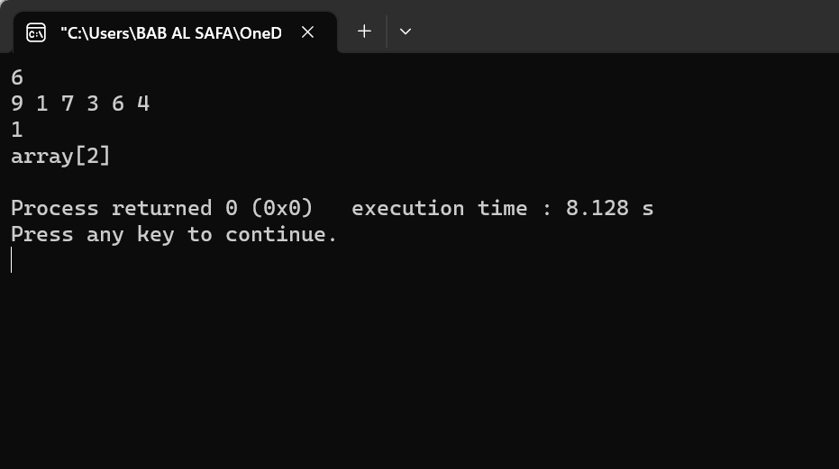

Fig 1.1: Output on console for case 1.

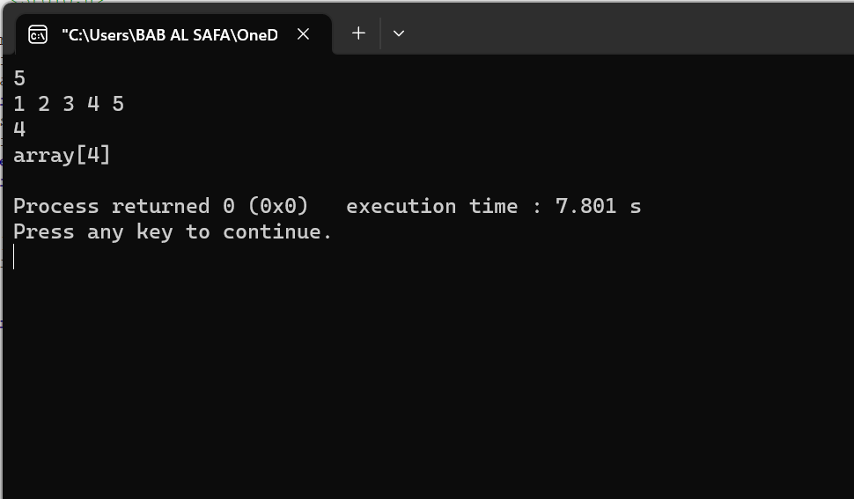

Fig 1.2: Output on console for case 2.

**Problem No.:** 02

**Problem Statement:**

Write a program that reads n numbers from the user and stores them in an array. Now perform the following operation using the switch statement. i. Prints the even numbers in reverse order. ii. Read a number from the user, and print “YES” if the number exists in the array. Otherwise print “NO”

**Code:**

#include <stdio.h>

int main() {

int n, x, h, l, m, flag=0;

scanf("%d", &n);

int a[n];

for(int i=0; i<n; i++)

scanf("%d", &a[i]);

for(int i=n-1; i>=0; i--)

if(a[i]%2==0)

printf("%d ", a[i]);

printf("\n");

for(int i=0; i<n-1; i++){

for(int j=0; j<n-1-i; j++){

if(a[j]>a[j+1]){

int tmp = a[j];

a[j] = a[j+1];

a[j+1] = tmp;

}

}

}

scanf("%d", &x);

h=n, l=0;

while(l<=h){

m=(l+h)/2;

if(a[m]==x){

printf("YES\n");

flag=1;

break;

}

else if(a[m]<x)

l=m+1;

else if(a[m]>x)

h=m-1;

}

if(!flag)

printf("NO");

return 0;

}

**Output:**

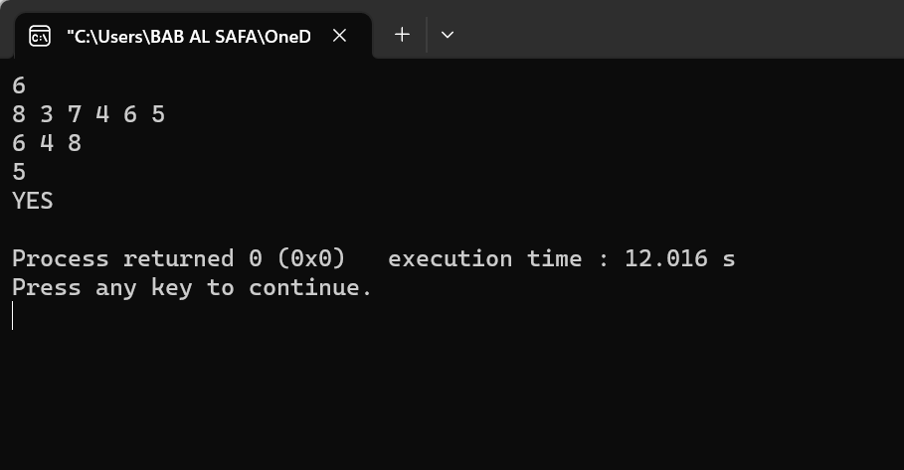

Fig 2.1: Output on console for case 1.

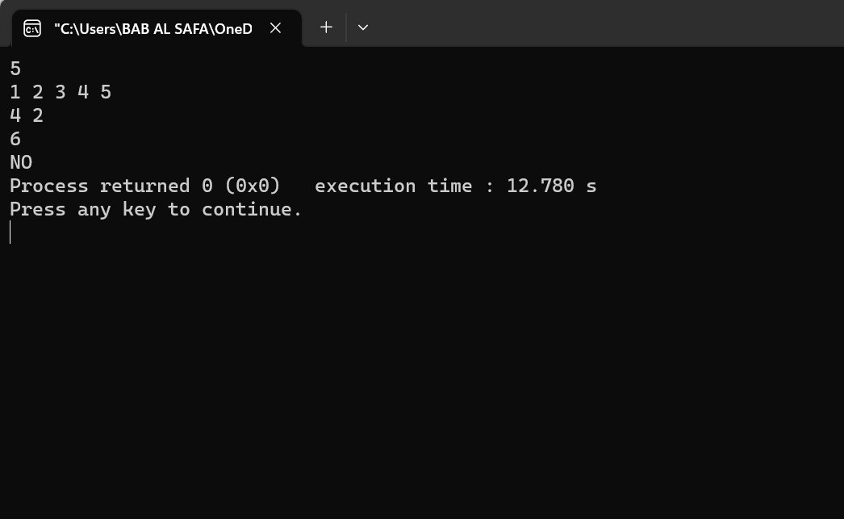

Fig 2.2: Output on console for case 2.

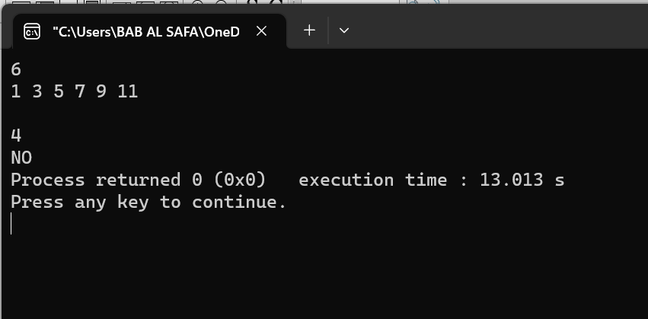

Fig 2.3: Output on console for case 3.

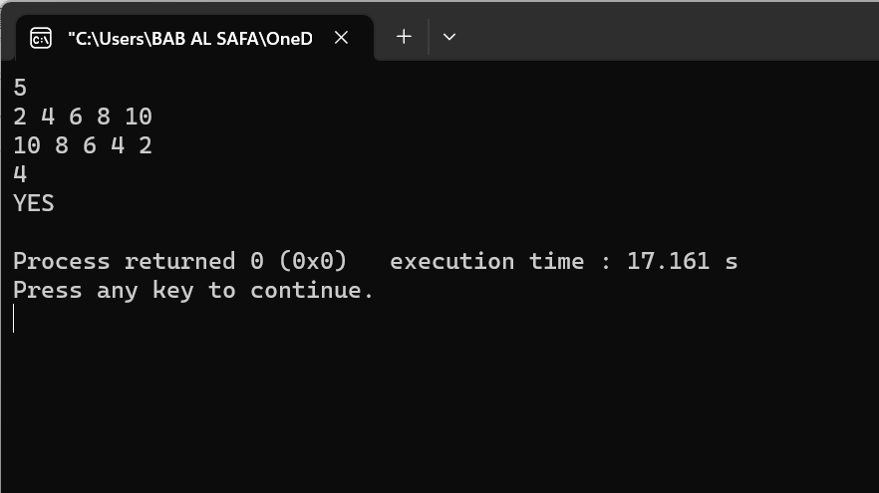

Fig 2.4: Output on console for case 4.

**Problem No.:** 03

**Problem Statement:**

Write a program that reads n numbers from the user, but does not allow the user to enter duplicates. This means that if a number has been entered already, the program will not accept it as input again and instead ask the user to enter a different number.

**Code:**

#include <stdio.h>

int main() {

int n, x, i=0;

scanf("%d", &n);

int a[n];

for(int i=0; i<n; i++){

scanf("%d", &a[i]);

for(int j=0; j<i; j++){

if(a[j]==a[i]){

printf("Enter a different number\n");

i--;

}

}

}

return 0;

}

**Output:**

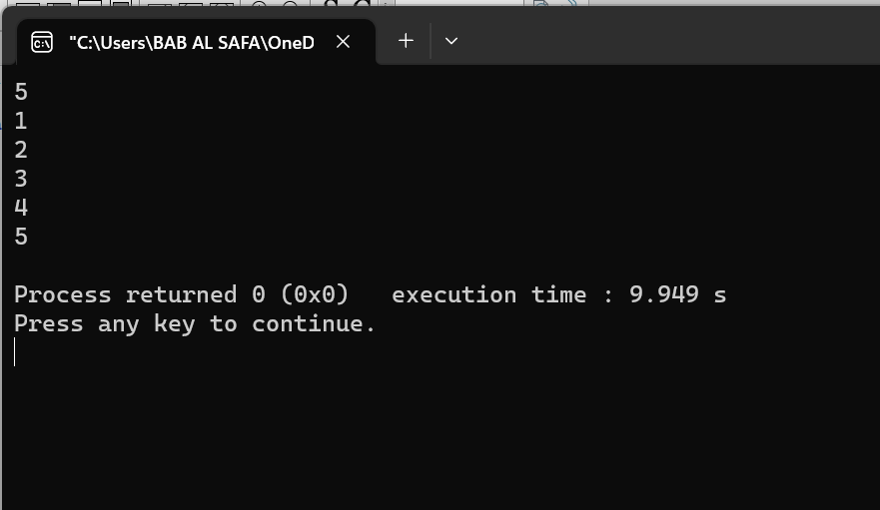

Fig 3.1: Output on console for case 1.

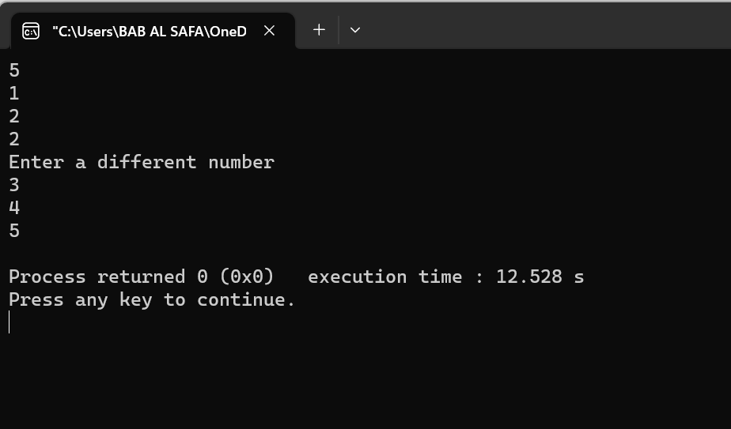

Fig 3.2: Output on console for case 2.

**Problem No.:** 04

**Problem Statement:**

Given two integer arrays of same size, “arr[]” and “index[]”, reorder elements in “arr[]” according to given index array. It is not allowed to given array arr’s length.

Input: arr[] = [10, 11, 12]

index[] = [1, 0, 2]

Output: arr[] = [11, 10, 12]

index[] = [0, 1, 2]

Input: arr[] = [50, 40, 70, 60, 90]

index[] = [3, 0, 4, 1, 2]

Output: arr[] = [40, 60, 90, 50, 70]

index[] = [0, 1, 2, 3, 4]

**Code:**

#include <stdio.h>

void bubble_sort(int *arr, int *index, int n){

for(int i=0; i<n-1; i++){

for(int j=0; j<n-1-i; j++){

if(index[j]>index[j+1]){

int tmp1 = arr[j];

arr[j] = arr[j+1];

arr[j+1] = tmp1;

int tmp2 = index[j];

index[j] = index[j+1];

index[j+1] = tmp2;

}

}

}

}

void print_array(int *a, int *indx, int n){

printf("arr[] = [");

for(int i=0; i<n; i++){

if(i<n-1)

printf("%d, ", a[i]);

else

printf("%d", a[i]);

}

printf("]\n");

printf("index[] = [");

for(int i=0; i<n; i++){

if(i<n-1)

printf("%d, ", indx[i]);

else

printf("%d", indx[i]);

}

printf("]\n");

}

int main() {

int arr1[]={10, 11, 12};

int index1[]={1, 0, 2};

int arr2[]={50, 40, 70, 60, 90};

int index2[]={3, 0, 4, 1, 2};

int n1=sizeof(arr1)/sizeof(arr1[0]);

int n2=sizeof(arr2)/sizeof(arr2[0]);

bubble_sort(arr1, index1, n1);

bubble_sort(arr2, index2, n2);

print_array(arr1, index1, n1);

print_array(arr2, index2, n2);

return 0;

}

**Output:**

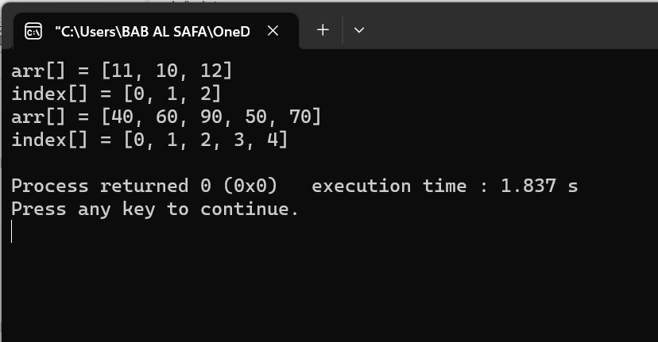

Fig 4.1: Output on console.